POWER BI DASHBOARD CHALLENGE

TASK 2 – DATA CLEANING (POWER QUERY)
● Detect and remove duplicates or missing values.
● Standardize column names and data types.
● Perform necessary transformations (split, merge, replace values).
● ✅ Task: Prepare a clean dataset for modelling.
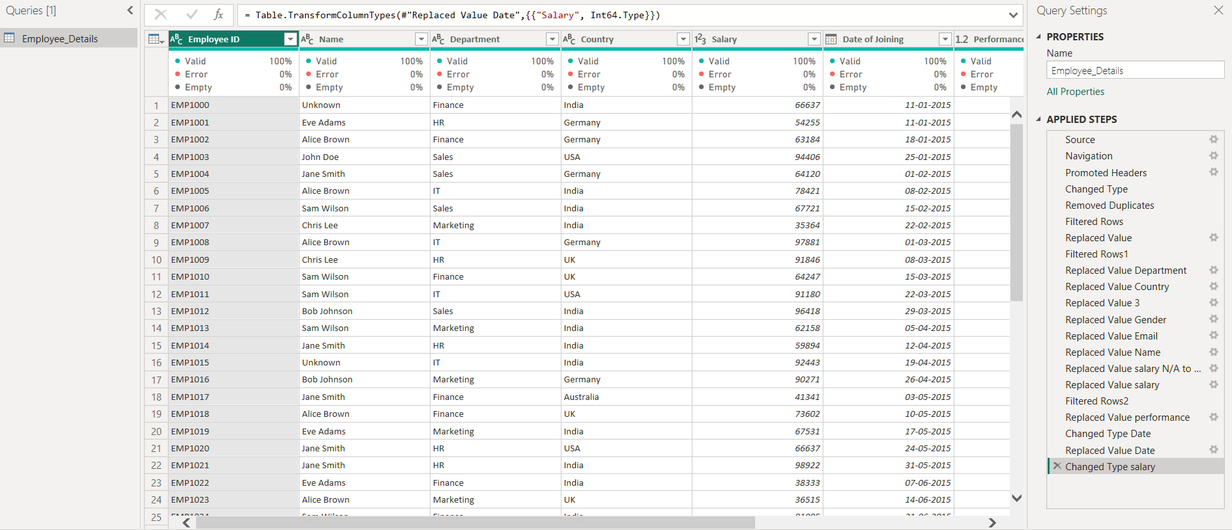
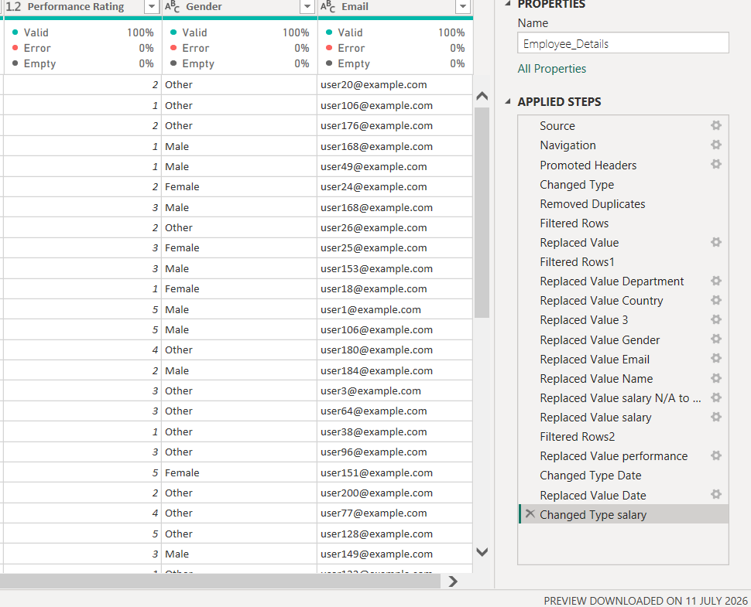
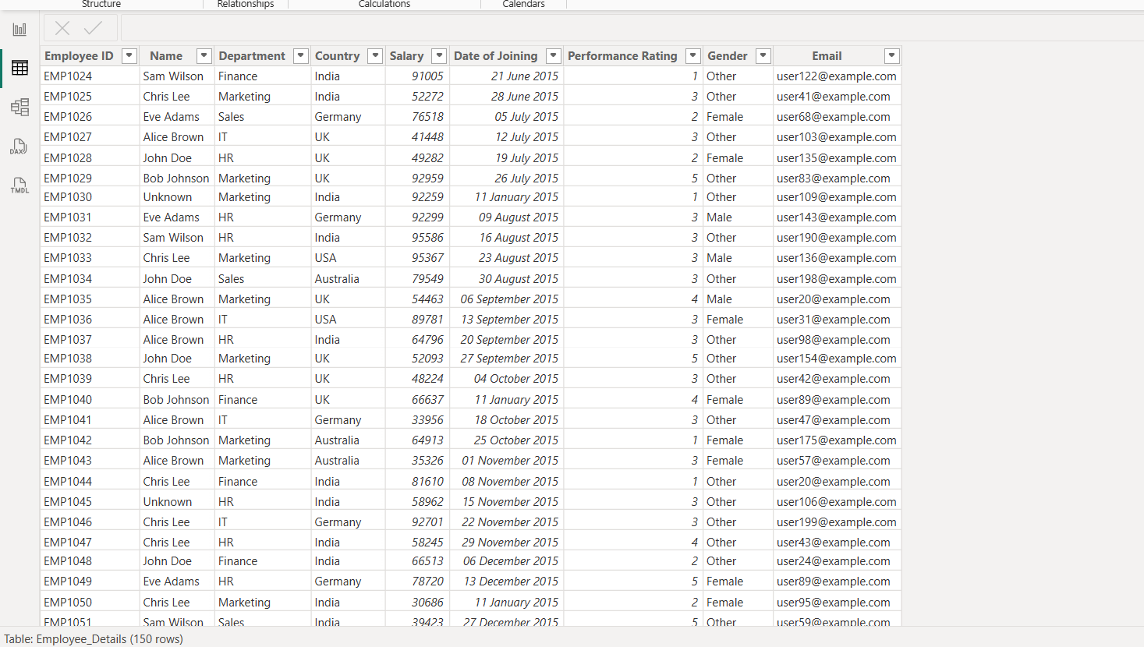

OBSERVATION:

- Duplicate records were identified and removed.
- Missing values were handled using appropriate methods (mode, median, or replacement).
- Invalid values such as N/A were corrected.
- Column names were standardized for consistency.
- Data types were assigned correctly to each column.
- Required transformations such as replacing values and formatting dates were completed.
- Data quality and consistency were improved.
- The final dataset is clean and ready for modelling and visualization in Power BI.

